Atitit mysql redis 二级缓存

实体实现序列化接口

Mapper

@CacheNamespace(size = 3000,implementation =RedisCache2JdsV2.**class**)

//@CacheNamespaceRef(value = null)

**public** **interface** CompanyMapper **extends** Mapper<Company> {

}

也可以使用官方对mybatis-redis cache实现。。 mbtsrds kch

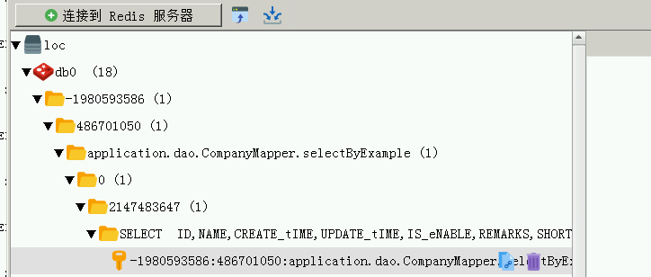

Uese rds cache..debug log,cant show hit cache again..but not output sql ,,so it shuold use reds cache...

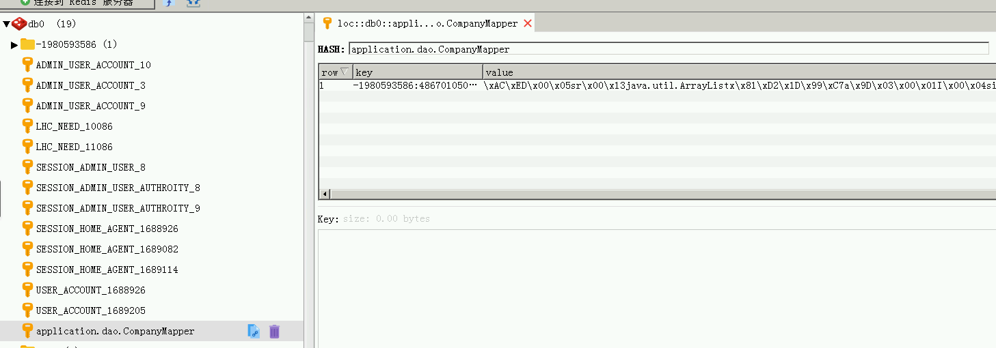

@Override

**public** **void** putObject(Object **key**, Object **value**) {

**try** {

*jds*.setex(**key**.toString(), 600, JSON.*toJSONString*(**value**));

***logger***.info( "putobj:"+id.toString());

***logger***.info(" value:"+JSON.*toJSONString*(**value**));

*jds*.setex(**key**.toString().concat("Bytemode").getBytes(), 600, SerializeUtil.*serialize*(**value**));

*jds*.hset(id.toString().getBytes(), **key**.toString().getBytes(), SerializeUtil.*serialize*(**value**));

// if(value instanceof String)

// jds.setex(key.toString(), 600, value.toString());

// else

//

// jds.set(key, value, EXPIRE_TIME_IN_MINUTES, TimeUnit.MINUTES);

// NX是不存在时才set， XX是存在时才set， EX是秒，PX是毫秒

// jedisClient.set(key, value, "NX", "EX", expireSecond);

***logger***.debug("Put query result to redis");

} **catch** (Throwable t) {

***logger***.error("Redis put failed", t);

}

}

/**

* Get cached query result from redis

*

* **@param** key

* **@return**

*/

@Override

**public** Object getObject(Object **key**) {

**try** {

// RedisTemplate redisTemplate = getRedisTemplate();

// ValueOperations opsForValue = redisTemplate.opsForValue();

// opsForValue.set(key, value, timeout, unit);

***logger***.debug("Get cached query result from redis");

***logger***.info( "getObject:"+id.toString()); // getObject:application.dao.CompanyMapper

Object o=SerializeUtil.*unserialize*(*jds*.get(**key**.toString().concat("Bytemode").getBytes())) ;

**return** SerializeUtil.*unserialize*(*jds*.hget(id.toString().getBytes(), **key**.toString().getBytes()));

// key -1980593586:486701050:application.dao.CompanyMapper.selectByExample:0:2147483647:

//SELECT ID,NAME,CREATE_tIME,UPDATE_tIME,IS_eNABLE,REMARKS,SHORT_nAME,COMPANY_sHORT_nAME,CMS_dOMAIN,PAY_dOMAIN,PC_iP,MOBILE_iP,APP_aPI_aDDRESS,APP_eMBED_aPI_aDDRESS FROM cOMPANY WHERE ( IS_eNABLE = ? ) order by SHORT_nAME ASC

//:true

// return jds.get(key.toString();

//jds.get(key.toString());

} **catch** (Throwable t) {

***logger***.error("Redis get failed, fail over to db", t);

**return** **null**;